STAT3011 Report — Explainable AI (Group 23)
- In the previous anomaly detection, a total of 13 outliers were found using the iForest model (identify outliers based on a threshold of 0.75). To further understand why these samples were classified as outliers, we would use SHAP for analysis.
- SHAP was chosen for its consistency and theoretical grounding, compared to LIME, it provides more stable explanations. Additionally, SHAP can be used for both local and global explanations, while LIME is limited to local explanations only.
- Given that international students face a greater risk of mental health challenges than the general student population, this section only focuses on outliers among international students.
- Among the 11 international student outliers, 10 are graduate students (90.91%), while graduate students account for only 9.95% of the full international student population, suggesting that graduate international students are over nine times more likely to be identified as anomalies.
- Graduate status is the dominant shared feature among anomalous international students, highlighting the need for targeted mental health support.
- Except for graduate status being the core shared feature, SHAP waterfall plots were used to identify other feature combinations that contributed most to the anomaly probability.
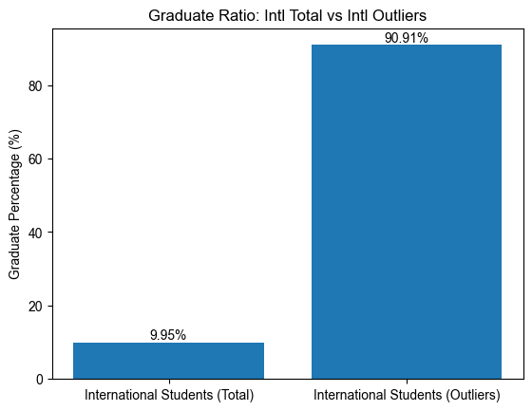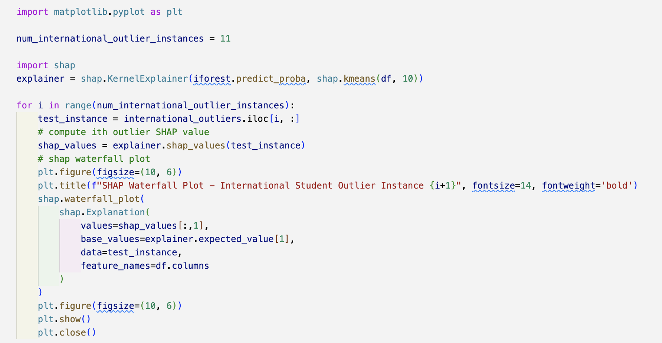
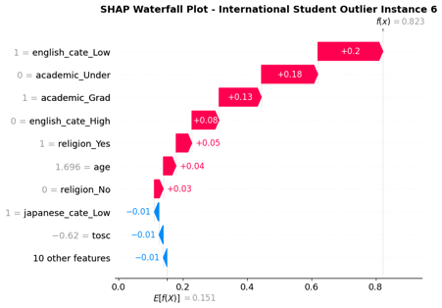
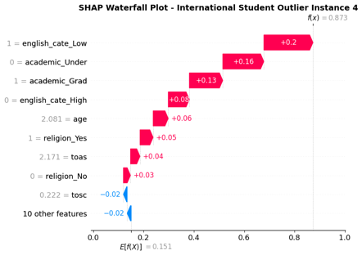
- Outliers with similar feature patterns are grouped into three major categories, with representative samples discussed below.
1) Language-Driven Outliers
a) For some outliers, in addition to graduate status, low English proficiency is an important driver of anomaly (outliers 4 and 6).
=>For international students, English is the primary tool
for daily communication and academic learning.
Insufficient proficiency can affect their academic
performance, increase social isolation, and intensify
psychological stress, which is consistent with the
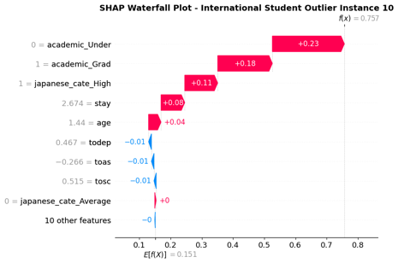
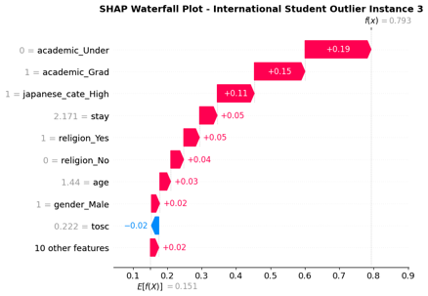
model assigning a positive SHAP contribution to low
English proficiency in these cases.

b) High Japanese proficiency also contributes greatly to
anomaly classification in some cases (outlier 3 and 10).
=> Although strong Japanese skills are generally
expected to support adaptation, these students may
still face integration barriers due to their foreign
status, leading to feelings of isolation and making
this feature combination anomalous.

2) Age and Social Connection-Driven Outliers
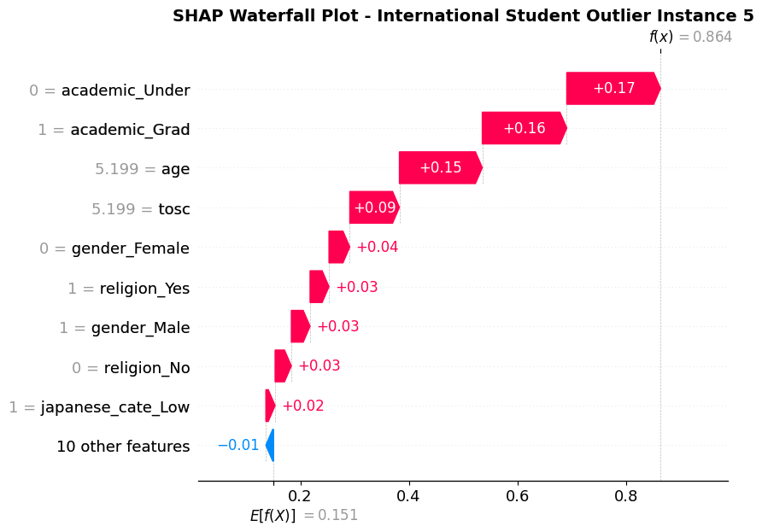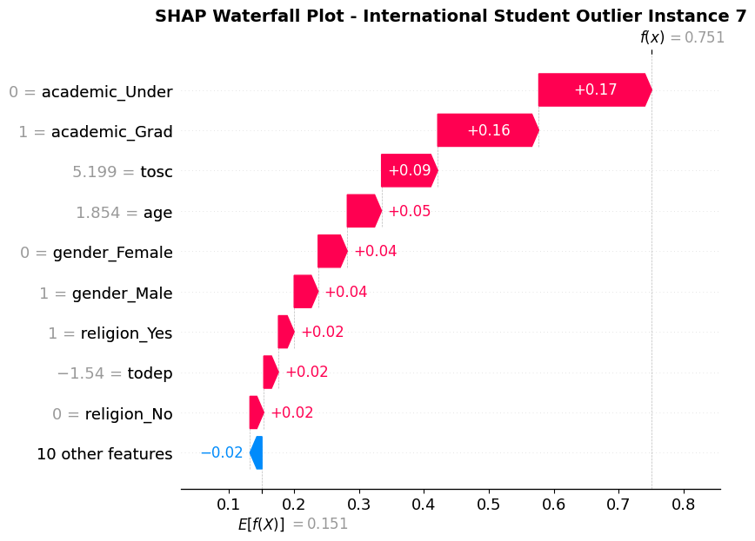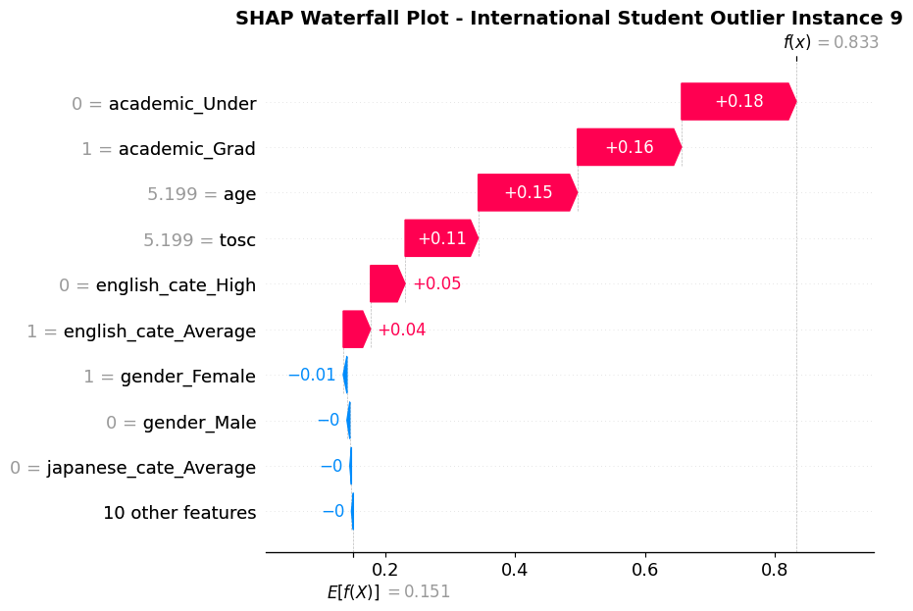
=> older age and greater social connection pressure may affect mental health of international students at the graduate level

3) Todep-Driven Outliers
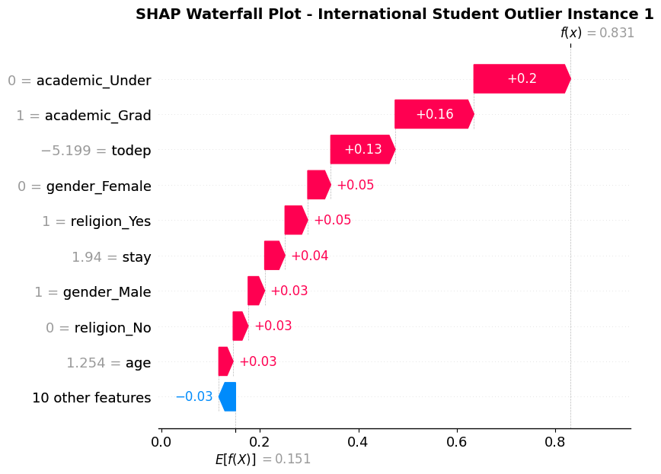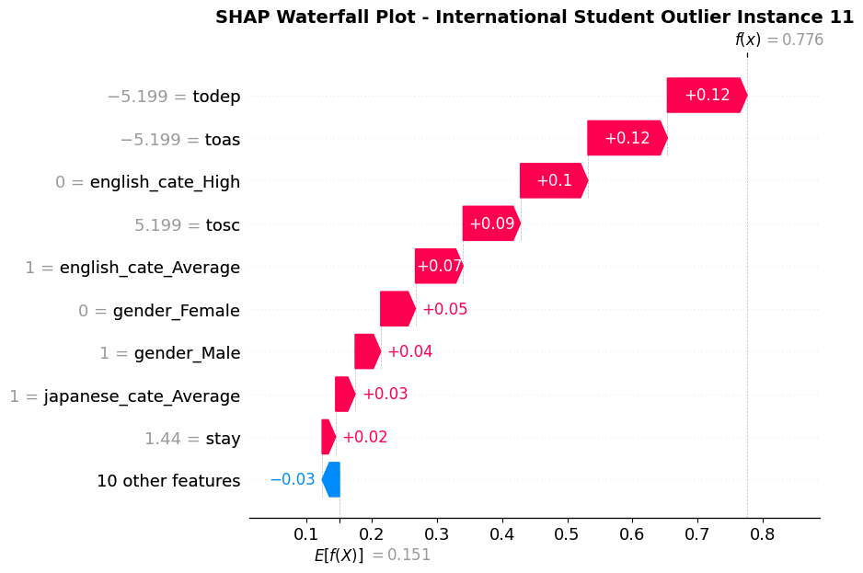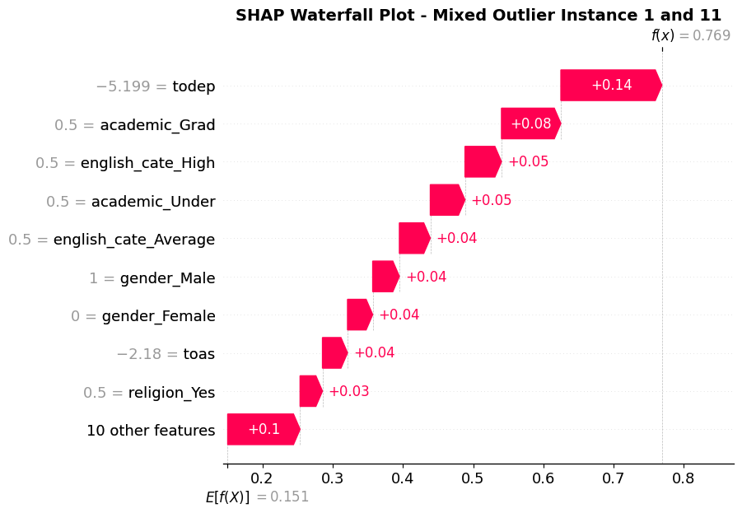
From both instances, we observe that extremely low todep (score of 0) contributes to high anomaly scores. After combining two samples and calculating SHAP scores again, we find that low depression, good English ability and low acculturative stress score contribute to high anomaly score => outliers that are well-adapted to university life
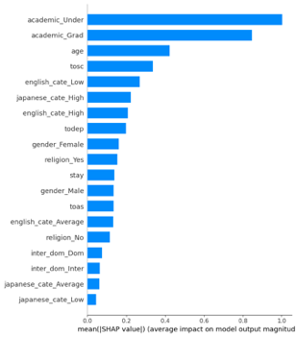
- Further global feature important plots also confirm that academic level, age, social connectedness, and language proficiency are significantly associated with a higher probability of being classified as an outlier, which is consistent with our findings from local SHAP waterfall plots.

- Conclusion: International students with graduate status, coupled with low English proficiency, high Japanese proficiency, or high social connectedness, are more likely to be identified as anomalous, highlighting patterns that may be associated with mental health challenges. These findings suggest that universities should pay closer attention to those international students.

